**CHAPTER 1 – INTRODUCTION**

**1.1 Background of study**

Taxi Business is as old as Nairobi itself. Before the advent of technology and mergence if taxi hailing, numerous taxi companies were operating in Nairobi Kenya. A taxi, also known as a cab or a taxicab, is a type of vehicle for hire with a driver, used by a single passenger or small group of passengers, often for a non-shared ride. A taxicab conveys passengers between locations of their choice. This differs from public transport where the pick-up and drop-off locations are decided by the service provider, not by the customers, although demand responsive transport and shared taxis provide a hybrid bus/taxi mode.

There are four distinct forms of taxicab, which can be identified by slightly differing

terms in different countries:

• Hackney carriages, also known as public hire, hailed or street taxis, licensed for

hailing throughout communities

• Private hire vehicles, also known as minicabs or private hire taxis, licensed for

pre-booking only

• Taxi Buses, also come in many variations throughout the developing

Countries as jitneys or jeepney, operating on pre-set routes typified by multiple

stops and multiple independent passengers

• Limousines, specialized vehicle licensed for operation by pre-booking

**1.2 Problem statement**

Driving a taxi can be a hazardous job, and many drivers experience assault, robbery, and other forms of violence every day. Violence is often a leading cause of taxi driver deaths, along with motor vehicle crashes. Police officers are also involved in taxi driver’s killings in suspicious circumstances. Harassment from some of their customers who threaten to finish them because they feel like they are being swindled by the taxi drivers in the name of exorbitant prices.

Such cases result in loss of life, children becoming either partial orphans or orphans totally and also this leaves a dent in the economy as these same people do help to build the nation and pay taxes. Furthermore the loss of taxi drivers also affects the transport industry which is a compliment to matatus and buses.

The ride-hailing companies like Uber, Little cab, etc. do not have any security measures to protect the driver. In addition to that, a certain percentage goes to these companies when a driver under the ride-hailing company carries a passenger thus reducing his/her income. There are no security measures put in place by the government or unions to protect the taxi industry. This leaves the taxi drivers to trust their instincts and more or less rely on the police to protect them.

**1.3 Aim of the study**

The taxi driver's security system's main aim is to create a platform where drivers will constantly update the activities involved while picking up and driving their customer to their destination. It will have its own meter payment system where the user will be charged based on the distance they travelled and the driver will receive the full amount with no remittance involved.

 Its simplicity would enable and ensure that the drivers are able to use the system without straining and ensuring fast responses from the police. The interface of the system which only requires registration of the user and he/she can use it at simple touch of the button.

Within a time frame of 6 weeks development of a website that will have backend for the dispatcher and frontend part for the driver...  It aims to target independent taxi drivers.

**1.3.1 Research objective**

The main objective of this project is to enable the taxi drivers to keep themselves safe with the help of the police. It will aim the driver to conveniently and periodically update his whereabouts, the clients he/she is driving and to receive payment from their client without any tussle.

Other objectives:

* Expand my knowledge base to increase security in the transport industry.
* Keep me up to date with the emerging security measures and trends.
* Build my credibility - This research and project will provide me with a good foundation upon which I can develop my thoughts and ideas
* Sparks connections - It will help me communicate better with others and convey why I pursue things.
* Encourage curiosity - It will help me spark curiosity as it will encourage me to explore and gain deeper insights into this subject matter. Curiosity leads to higher levels of positivity and lower levels of anxiety.
* Learn through the project this is inclusive of the literature review.
* Design and develop software

**1.4 Significance/Justification of the study**

The taxi driver’s security system will benefit private taxi driver owners in that it will help alleviate harassment cases from customers and the police. It intends to curb the number of deaths and robbery in the transport industry. With this system the drivers will be able to request help and report the threats posed to them in a timely manner and thus reduce the number of deaths and loss cases.

**1.5Scope**

The major stakeholders that will be involved in this project will be the supervisor, me (developer) and the taxi drivers.

The system will entail a web application. The web application will enable the driver to:

* Create an account
* Notify a dispatcher when:
  + When picking up a passenger.
  + If a passenger changes their destination once they’re in the taxi.
  + If driving to a certain area feels potentially unsafe.
* Checking in regularly with the dispatcher.

Technologies to be used will entail HTML, CSS, JavaScript, python and pivotal tracker to track my progress. All these activities are scheduled to happen in a period of 6 weeks.

The local Kenyan drivers will be the main stakeholders in this system.

**1.6 Assumptions**

The main assumption while developing this system will be that the drivers are either computer literate or know how to use a smartphone. This entails using the internet and dialing.

The driver must have a roadworthy car allowed by the transportation authorities (NTSA).

Another assumption is that the police and the judiciary system will be ready to cooperate and be able to respond immediately.

**1.7 Limitations**

A major concern for this system to work is to be integrated with the current security policies and protocols in place. As per now locally in Kenya the police system is that most things are done physically and manually. The call free toll system 999 and 911 rarely works and at times the police assume calls and don’t take them seriously to some extent. The response time is also not fast enough and it takes a second for the damage to be done.

Another limitation is that internet connection is required. Data bundles and internet connection is quite expensive which poses a challenge.

**Chapter 2 - Literature Review**

**2.1 Introduction**

This chapter reviews literature related to the study objectives based on the high rise of insecurity taxi drivers in Kenya. Literature review seeks to bring out the existing body of knowledge relevant to taxi drivers security, critic the work and identify the gaps. These gaps motivate the study to advance the body of knowledge on taxi drivers' security.

The purpose of this chapter is to review relevant literature information that is related and consistent with the objectives of the study. Important issues and practical problems will be brought out and critically examined so as to determine the current facts. This section will be vital as it determines the information that links the current study with past studies and what future studies will still need to explore so as to improve the knowledge. The following are related work that has been done before on improving the security of taxi drivers.

**2.2 Related systems**

**2.2.1 Keen Track**

Keen Track is a reliable car tracking, fleet management systems, anti-theft car alarms and vehicle security systems supplier in Kenya. They offer high quality car tracking systems and car alarms at competitive prices.

**2.2.2 WorldEyeCam**

They offer quality video surveillance systems at an affordable price for taxi drivers. WorldEyeCam offers a full line of **DVR**s, **NVR**s and **CCTV** security camera products from a trusted veteran of the security world.

**2.2.3 247 Security**

Their main objective is ensuring the drivers as well as the passengers are recorded with their highly sophisticated CCTV cameras installed in the taxis. They studied the market and the result was **TVS6,** a Taxi video system. They have designed a reliable and compact system that helps drivers and passengers feel secure, and law enforcement confident that they have solid video evidence. 247Security has developed a video system that meets everyone’s needs in the Taxi industry.

**2.2.4 Smart taxi security system design with IoT**

This system is suggested to protect the asset, which is a taxi. The system will use the Euclidean distance method which is a method used to calculate the distance of the incident and the nearest police station. By using the progress of technology, the progress can be utilized to help the security of taxis owned by a company or personnel. IoT will help to secure a taxi since it is able to locate the incident’s location precisely and accurately.

**2.2.5 MCD security systems ltd**

They released a fit CCTV system in Rotherham Private and Hackney Carriage vehicles. There systems are full **HD** 1080p which ensures clarity of images recorded. The systems offer up to 30days recording, manual on/off switches for drivers to turn the system off when using a vehicle for private use and panic/audio switches for both passenger and driver.

**2.3 Limitations of these systems.**

The named systems aim to serve a purpose that is to enhance the security of the taxi driver and the passengers. Nevertheless the systems have loopholes which still put the taxi driver at risk and threaten their lives.

One of the limitations in the keen tracking systems is that it tracks the taxi vehicle. This means that it can only be used to identify the location of the car if it is reported stolen. This only keeps tabs on the car but not the taxi driver. For the vehicle to be stolen it could be that the driver was attacked or drugged. Meaning the driver is always vulnerable.

Another limitation is that most of these surveillance systems are used to record and store the recordings for future reference as evidence. Some have live streaming but there's no one on the other end watching and keeping track of the happenings and intervening if anything out of the ordinary was to happen.

The surveillance systems require the user that is the taxi driver, to receive a proper training of the equipment installed in his/her vehicle. That includes making backups of the recordings, copying the tapes or connecting it to the internet to update the servers. This poses a challenge as many taxi drivers in Kenya are not literate to a level of understanding the technical knowhow of these systems. The taxi drivers at times end up tampering the default or configured settings of the equipment. To some extent they also reset the system or reboot it, erasing all stored backups. . Their education increases the overhead cost of time and installation costs to install the CCTV.

In addition to the local systems like Keen tracking systems. The other systems are not locally available and shipping them to Kenya poses an extra cost which the taxi driver cannot meet. The installation cost for the new system does not come cheap and thus many drivers opt to not have them in the first place.

**2.4 Proposed solutions to these limitations.**

With the given limitations I aim to solve some of these problems with the project where there will be a second party involved to enhance the driver’s security.

The main purpose of this project is the driver to constantly report or inform a dispatcher, preferably someone in the police of all the activities that the driver is involved in. It ranges from the time they start working, to picking passengers to the time they call it a day and head back home to their families.

In terms of being able to keep track of the driver. The implementation will have a location enabled feature that will show where the driver is currently located. In addition to that every time the driver picks up a passenger, they have to inform a dispatcher and they will pass on the details about the passenger for future references and for the security of the driver. In case the passenger wants to change their destination the driver has to relay the same information to the dispatcher.

The system will be a plug and play type of system. After the driver creates an account they can start using the system. It will have a simple interface and with the help of the dispatcher on call they will be able to navigate the system easily without interruptions on their daily activities.

A distress button will be available in the system to be used for emergency purposes. This may be involved when the driver is being attacked or is being held at gunpoint. Simply put if the driver’s life is in danger the distress button comes to play. When they press this button the dispatcher on the other end will immediately inform the authorities and thus effect an immediate response to save the driver.

**Chapter 3 – Methodology**

**3.1 Introduction**

This chapter describes the methodology that will be used in developing the Taxi driver’s security system. It entails description of tools and methods that will be used in achieving the objectives of the proposed system.

**3.1.1 System development life cycle**

A system development methodology refers to the framework that is used to structure, plan, and control the process of developing an information system. When it comes to software development SDLC is the process that takes place. It consists of a phase that system developers follow during the process of system development. There are different methods of system development life cycle and for this I will be using agile methodology.

**3.2 Methodology**

**3.2.2 Agile Methodology**

The term "agile methodology" refers to a practice that encourages continuous development and testing throughout the project's software development lifecycle. Unlike the Waterfall paradigm, both development and testing operations are contemporaneous under the agile model of software testing.

An agile methodology is an iterative approach to software development. Each iteration of agile methodology takes a short time interval of 1 to 4 weeks. The agile development process is aligned to deliver the changing business requirement. It distributes the software with faster and fewer changes.

The single-phase software development takes 6 to 18 months. In single-phase development, all the requirement gathering and risk management factors are predicted initially.

The agile software development process frequently takes the feedback of workable products. The workable product is delivered within 1 to 4 weeks of iteration.

**Roles in Agile**

There are two different roles in an Agile methodology. These are the Scrum Master and Product Owner.

**1. Scrum Master**

The Scrum Master is a team leader and facility provider who helps the team member to follow agile practices, so that the team member meets their commitments and customers requirements. The scrum master plays the following responsibilities:

* They enable the close co-operation between all the roles and functions.
* They remove all the blocks which occur.
* They safeguard the team from any disturbances.
* They ensure that Agile Inspect & Adapt processes are leveraged correctly which includes
  + Planned meetings
  + Daily stand-ups
  + Demo
  + Review
  + Retrospective meetings, and
  + Facilitate team meetings and decision-making process.

**2. Product Owner**

The Product Owner is one who runs the product from a business perspective. The Product Owner plays the following responsibilities:

* He defines the requirements and prioritizes their values.
* He sets the release date and contents.
* He takes an active role in iteration and releasing planning meetings.
* He ensures that the team is working on the most valued requirement.
* He represents the voice of the customer.
* He accepts the user stories that meet the definition of done and defined acceptance criteria.

**3.2.3 Justification of Agile Methodology**

Agile approach isn't only a set of rituals or a set of development techniques. Rather, it is a collection of approaches that demonstrate a commitment to continuous development and tight feedback loops.

To meet targeted delivery time frames, this methodology works in iterations, with each iteration lasting 10 to 15 days. The original Agile Manifesto, however, did not specify a two-week iteration timeframe or an optimum team size.

This methodology involves tremendous awareness of the project which enables catching and addressing issues quickly.

**3.3 Data collections**

Data collection is the process of gathering, measuring, and analyzing accurate data from a variety of relevant sources to find answers to research problems, answer questions, evaluate outcomes and forecast trends and probabilities.

This project is highly dependent on data, which underscores the importance of collecting it. Accurate data collection is necessary to ensure quality assurance and keep research integrity.

**3.3.1 Data collection Methods**

Data collection methods can be broken down into two methods.

1.      Primary – This is original, first-hand data collected by the data researchers.

2.      Secondary data is second-hand data collected by other parties and already having undergone statistical analysis. This data is either information that the researcher has tasked other people to collect or information the researcher has looked up.

The main primary data collection methods in this project will entail:

·         Interviews – I will ask questions from a large sample of people by means of direct interviews.

·         Focus groups – It involves anywhere from a half-dozen people, led by a moderator, brought together to discuss the issue.

·         Questionnaires – respondents will get a series of questions, either open or close-ended, related to the matter at hand.

The main secondary Data collection methods in this project will entail:

·         The internet

**3.3.2 Data collection tools**

Data collection tools refer to the devices/instruments used to collect data, such as a paper questionnaire or computer-assisted interviewing systems. Tools involved in this project will be:

* Word Association - Respondents will receive a set of words and ask what comes to mind when they hear each word.
* In-Person Surveys – The researcher asks questions in person.
* Observation – It will be effective in small-scale situations

**3.3.3 Data sets**

A data set is a collection of data. The main sources of data sets will be from the internet which will include blogs and journals. Open police records will also be used.

**Chapter 4 System Analysis**

**4.1 Detailed analysis of current system.**

The essential components of an Information System, how data moves within the system, user-interaction points, and the Authorization Boundary are all captured in the Information System/Data Flow Diagram.

**4.1.1Flowchart**

Flowchart is a diagrammatic representation of sequence of logical steps of a program. Flowcharts use simple geometric shapes to depict processes and arrows to show relationships and process/data flow.

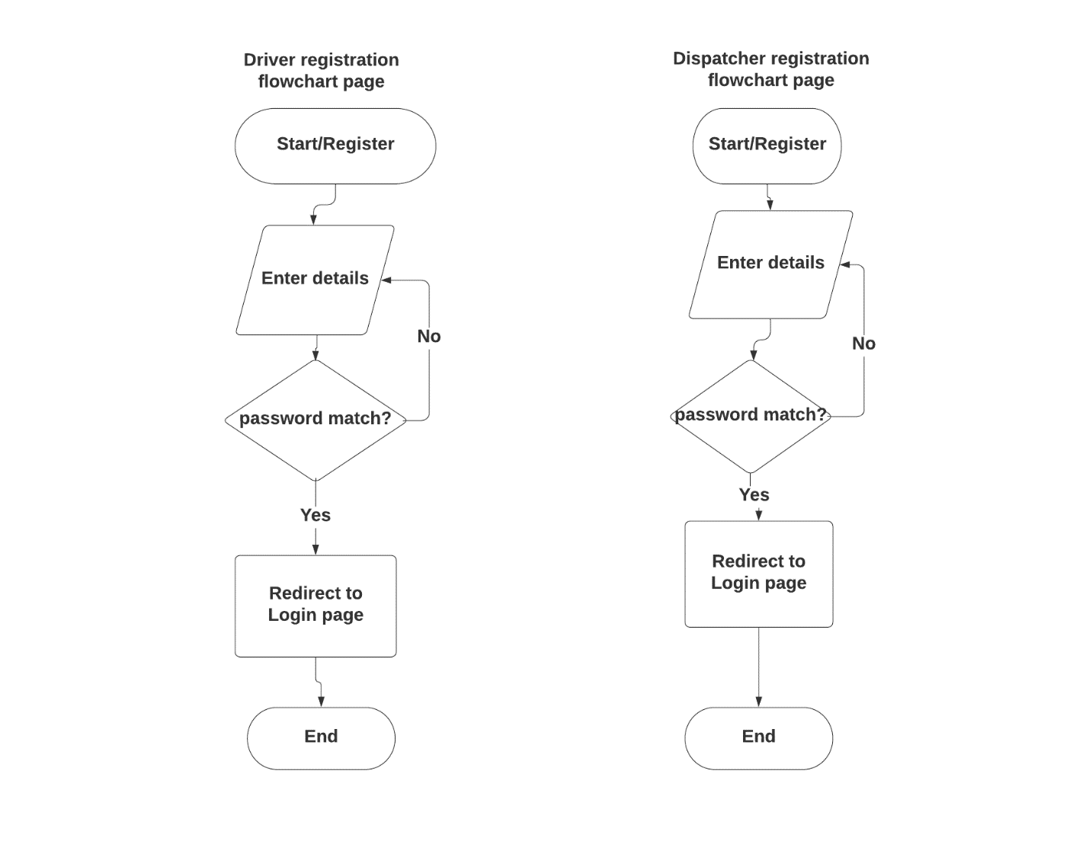

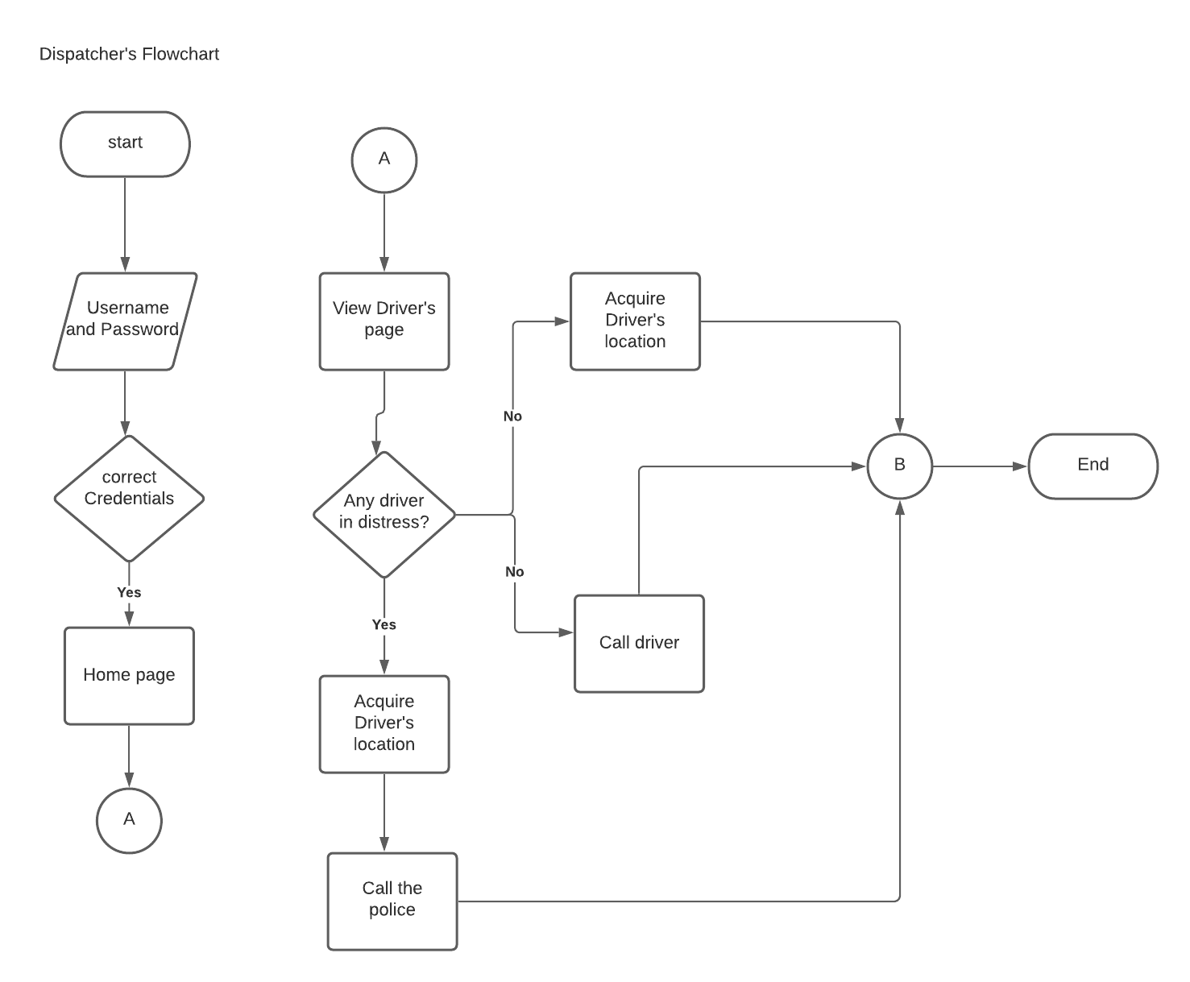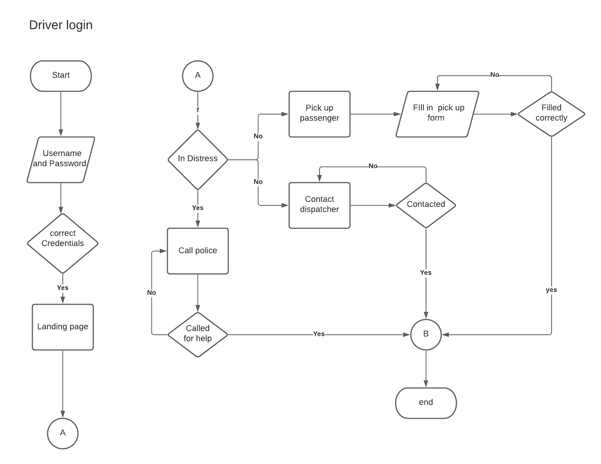

**­­­­­**

**4.1.2UML Use case diagram**

The primary form of system/software requirements for an undeveloped software program is a UML use case diagram. The intended behavior (what) is specified in use cases, not the actual technique of achieving it (how).

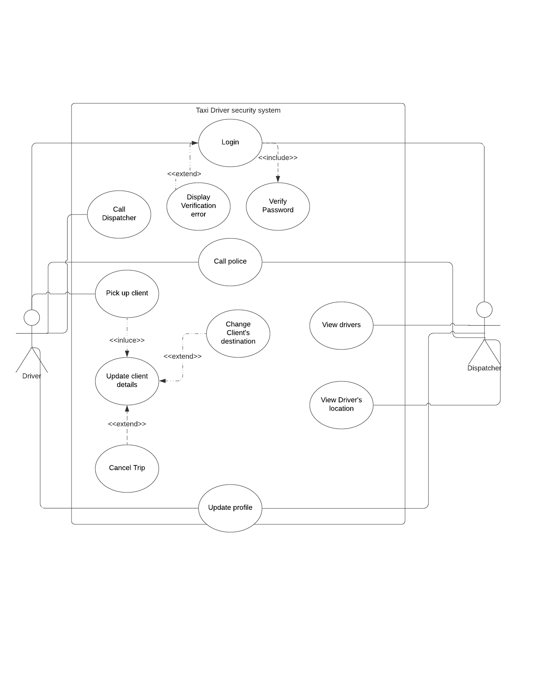

**4.1.3Context diagrams**

The Context Diagram depicts the system in question as a single high-level process, followed by the system's connection with other external entities (systems, organizational groups, external data stores, etc.).

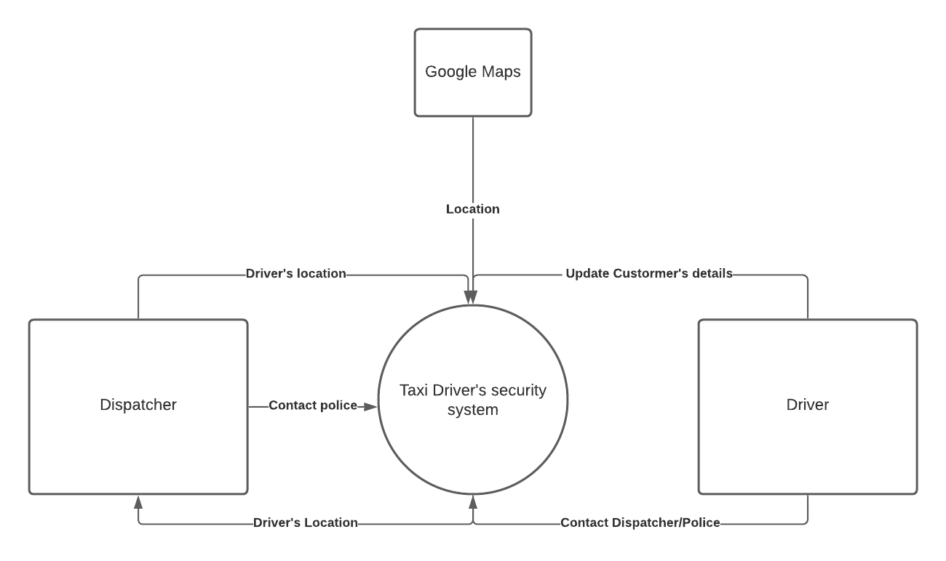

**4.2 System requirements**

The features and behavior of a system or software application are described in system requirements. It consists of a number of parts that seek to define the customer's intended functionality in order to please their various consumers. In addition to stating how the system should act, the specification also describes at a high-level the core business processes that will be supported, what simplifying assumptions have been made and what critical performance parameters will need to be met by the system.

**4.2.1 Functional requirements**

A Functional Requirement (FR) is a statement that describes the service that the software must provide. It refers to a software system or a component of one. A function is nothing more than the inputs, behavior, and outputs of a software system. A calculation, data manipulation, business procedure, user interaction, or any other unique functionality that defines what function a system is likely to execute can all be considered. Functional Requirements are also known as Functional Specification in Software Engineering. A Functional Requirement can range from a high-level abstract explanation of the sender's need to detailed mathematical functional requirement specifications in software engineering and systems engineering. Functional software requirements assist you in capturing the system's intended behavior.

The driver should be able to:

1. Register his/her credentials in the system.
2. Log in to the system.
3. See and change their profile details.
4. Call the police directly.
5. Interact with the dispatcher.
6. Fill in details when they pick up their passengers. This includes:
   1. Picking up a passenger.
   2. Fill in change of destination.
   3. Press the distress button.
   4. Press the arrived button.

The dispatcher should be able to:

1. View and update his profile
2. See the registered drivers in the system.
3. Interact with the driver.
4. Call the police.
5. Acquire driver’s locations.

**4.2.2 Non-Functional requirements**

The limits or requirements imposed on the system are known as non-functional requirements. They define the software's quality attribute. Scalability, maintainability, performance, portability, security, and dependability are all examples of non-functional requirements. Non-Functional Requirements address critical software quality issues.

The system needs:

* A browser
* A computer with preferable with over 2gb ram
* A database host
* Access to google maps API
* Database security
* Working internet connection or locally hosted server XAMMP server.